# Sprint 2 Plan - Planetarium

Scrumbags

## Sprint Completion 11/7/2023, Revision 2, 10/25/2023

# Goal

Create the basic and foundational functionality and UI for the application. Establish infrastructure and get familiar with Flutter and Firebase.

# Task Listing

Check [here](https://plannertarium.atlassian.net/jira/software/projects/PLANNER/boards/1) for the most up to date view.

As a user, I want to be able to…:

1. See my inputted information when I reopen the app so that I do not need to keep it open - 13pt
   1. Add user authentication to track user accounts - 8pt
   2. Create methods to read user data from the database into memory upon app launch - 5pt
2. Create tasks so I can add tasks to my schedule - 2pt
   1. Create methods that save a task object to the database - 2pt
3. Click on tasks to see more information about them - 8pt
   1. Create a new Widget on the UI to accept new tasks - 2pt
   2. Display tasks in daily view - 2pt
   3. Display tasks in weekly view - 2pt
   4. Display tasks in monthly view - 2pt
   5. Link the UI Widget to the new method - 0pt
4. Change properties of a task so that I can mark them as completed, move to another date, etc - 2pt
   1. Add getters and setters to Task class to update their attributes - 2pt
5. Click on properties of a task so that I can change them as necessary - 5pt
   1. Add UI for swipe left on a task Widget - 2pt
   2. Add UI for swipe right on a task Widget - 0pt
   3. Add UI for double tap on a task Widget - 1pt
   4. Add UI for holding down on a task Widget - 1pt
   5. Add UI for moving tasks to different times on the timeline - 1pt
6. Create events so that I can add new events to my schedule - 1pt
   1. Create methods that save an event object to the database - 1pt
7. Click on events so that I can see more information about them - 8pt
   1. Create a new Widget on the UI to create new events - 2pt
   2. Display events in daily view - 2pt
   3. Display events in weekly view - 2pt
   4. Display events in monthly view - 2pt
   5. Link the UI Widget to the new method - 0pt
8. Change properties of an event so that I can change details about location/time/etc - 8pt
   1. Add getters and setters to Event class to update their attributes - 1pt
   2. Create recurrence functions to set an event as recurring - 2pt
   3. Support infinite recurrence - 5pt
9. Click on properties of an event so that I can see more detail - 2pt
   1. Add UI for moving events to different times on the timeline - 2pt
10. Switch between time windows so that I can plan for the short, medium and long term as needed - 5pt
    1. build the screen for the daily view - 2pt
    2. build the screen for the monthly view - 1pt
    3. add UI buttons and swipe gestures - 2pt

# Team Roles

Steven Xue - Backend developer

Liam Xu - Frontend developer

Andrew Hu - Frontend developer, Backend developer

Andrew Yegiayan - Backend developer

Cheng Wai Chong - Frontend developer

# Initial Task Assignment

Cheng Wai Chong - US3, Create a new Widget on the UI to accept new tasks

Liam Xu - US6, build the screen for the daily view

Andrew Yegiayan - US1, Add user authentication to track user accounts

Steven Xue - US8, Add getters and setters to Event class to update their attributes

Andrew Hu - US4, Add getters and setters to Task class to update their attributes

# Initial Burnup ChartSprint 2 Burnup Chart, Plannertarium

# Initial Scrum Board

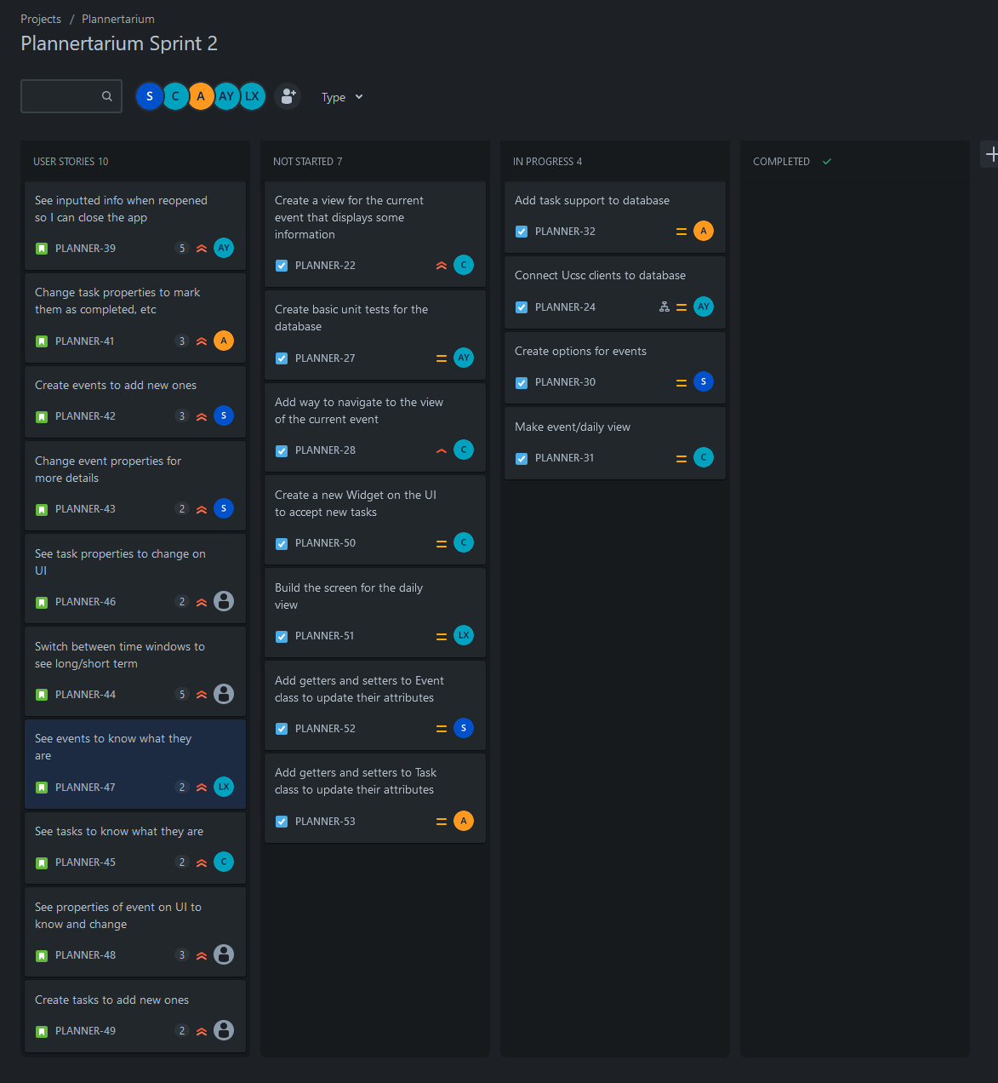

# Scrum Times

Monday 12:15pm

Wednesday 6pm

Friday 6pm